National Institute of Personnel Management, Karnataka Chapter, Elections to the Executive Committee – 2016

MANIFESTO of Dr. James Thomas, a contestant for the Chairmanship of NIPM – Karnataka Chapter.

Preface

Elections to the Executive Committee of NIPM are to be held shortly. The contestant respectfully seek your mandate to become the next Chairman of NIPM – Karnataka Chapter. To set the context right, would like to bring up certain concerns raised by members of the Association during many interactions we had.

- NIPM is not having a progressive outlook, like other HR organizations have.
- Youngsters are not becoming members.
- Attendance for the meetings and programs is coming down.
- Karnataka Chapter does not have a visibility and also there is no representation at the National level.
- The perception of many HR professionals is that NIPM is only for IR professionals and is predominantly represented by members from manufacturing companies.

Many of the Associations are facing various challenges to manage, especially dwindling membership, participation is becoming very minimal and interest to participate in various programs have been decreasing. May be because of increasing use of social media and dependency on internet for immediate answer to various questions.

I am sure that though internet and social media are very essential for a HR professional, meeting once a month and sharing the experiences in person and networking is also very important for a Human Resource Professional. I trust all of you would agree with me. I have taken it up as my mission to make a difference, would definitely bring in young talents and work for the development of our HR fraternity.

The Way Forward : 2016 - 2018

After various discussions and deliberations with progressive HR professionals I have prepared a road map that could take us way forward in serving the HR fraternity as well as the Profession of Human Resources for the next two years.

Some of the objectives are

- To ensure high standards in the conduct and managing the affairs of NIPM Karnataka Chapter and also ensure to bring it up as the best Chapter in India as well as a model Association for all other Professional HR Associations in India.
- To ensure participation of maximum number of Management Institutes and involve students in all activities, so that in future a good number of them will join the Association.
- To conduct periodic programs for the young minds related to HR.
- To organize an international seminar in the field of HR.
- To organize a National Level Quiz competition for the students of all Management Institutes in India every year. This would be held as a National level event every year.
- To organize a State level Women Throw ball championship tournament for all corporates in Karnataka. This would focus more on creating awareness on breast cancer and the role of HR in understanding the issues faced by women employees.
- To organize a State level Corporate Annual Cricket Tournament for Men every year.
- To introduce insurance for the members of Karnataka Chapter.
- To organize Career guidance for the students.
- To improve the intake of Diploma students.
- To form a separate cell for the women HR professionals under the banner of NIPM Karnataka Chapter. This cell would primarily work on issues related to women at workplace and give guidance to women employees, organize programs for women employees reg. work life balance, health awareness and so on. NIPM – Karnataka Chapter’s website will have one more page dedicated to them.
- To start a help line for 'Sexually harassed Women Employees' and Legal assistance would be given to them wherever possible.
- To form an Employment Cell for the existing members of the Association for career advancement. Job portal will be enabled along with the Karnataka Chapter’s website. All members could post their job opening, upload resumes, job search, resume search and so on.

Suitability of Dr. James Thomas for the position
It is very important when committing to perform par excellence and one must look at the competency of the person who has committed. It is imperative to look at my profile and I place on record my credentials to contest for the Chairmanship of NIPM Karnataka Chapter.

Professional Experience
Has about 26 years of experience in various fields covering Research, Teaching, H. R. Consulting etc., and holding the position of Sr. General Manager and Head, Human Resources and Administration in Page Industries Ltd., (Jockey India) world’s largest licensee (for India, Srilanka, Bangladesh, Nepal and UAE) of Jockey International, employed around 20,000 employees in 18 locations in Karnataka and Tamil Nadu and sales team spread across the breadth and width of India.

Has also worked as General Manager and Head of HR with Gokaldas Exports Ltd., a Blackstone company, employing more than 40,000 workforce in 30 different locations in South India. Prior to Gokaldas, he was the General Manager – Organization Development/Corporate HR at Shahi Exports Pvt. Ltd., employing more than 100000 workforce presently. He had worked with Esix Technologies Pvt. Ltd., a software development company located in Chennai as Manager – Human Resources and Kumaran Systems Pvt. Ltd., as Sr. Executive heading the Onsite Consulting - Recruitment Division at Tidel Park, Chennai). He has also worked with many other organizations in various capacities and he had a stint with University of Mysore as a Faculty.

Education
He has completed Bachelor of Arts (BA) from St. Philomena’s College, Mysore with First Class, Master of Social Work (MSW) from the University of Mysore, Mysore with First Class and First Rank, and Doctor of Philosophy (Ph. D) in Social Work from the University of Mysore, Mysore.

He has undergone a Certificate course in SAP R/3 Human Resource Module Training from TeamSAP Academy, Sapient College, Siemens Information Systems Ltd., Chennai, and a Certificate Course in SPSS PC + Package sponsored by the Indian Council of Social Science Research, New Delhi and conducted by the Tata Institute of Social Sciences, Mumbai.

He has attended a Management Development Program at XLRI, Jamshedpur and also attended a 10 day residential program for the Senior Management team at Sumedhas, The Academy for Human Context, Chennai.

Other credentials
- He has participated in more than 50 Seminars / Conferences / Workshops related to HRD and Social Work Education.
- He has received a total of 6 Merit Scholarships.
- He was the Member of CII, Karnataka Chapter in the HRD forum for many years.
- He has been a member of the CII delegation to Singapore and Malaysia to study the best practices in HR during 2004 (Visited Singapore Airlines, Malaysian Airlines, Citi Bank, PETRONAS Towers, May Bank, Singapore Port to name a few).
- He had been to Srilanka for a couple of times to study the best practices in NIKE factories, visited MAS Active, Hirdramani Group factories, Bodyline, Linea Intimo, Fonterra, Greenkeepers etc.,
- He was the Member of Board of Studies, Department of Studies in Social Work, University of Mysore.
- He is the Founder and Managing Trustee of SNEHA (Society for New Environment and Humanitarian Action), an NGO, working towards the development of women and children, Bangalore.
- Presently the President of MSW Socialites, an Alumni Association of the Department of Studies in Social Work, University of Mysore.
- He is a member of Rotary Bangalore National Park and Director for Community Services.
- He is the PATRON member of The Textile Association (India).
- He is presently the members of Education and Training Committee of Federation of Karnataka Chamber of Commerce and Industries, Bangalore.
- He is one of the Advisory Committee Member of Centenary Celebrations Committee of the University of Mysore to be held in July 2016.
- He is the recipient of HR Leadership Award in 2013 form Employer Branding Institute.
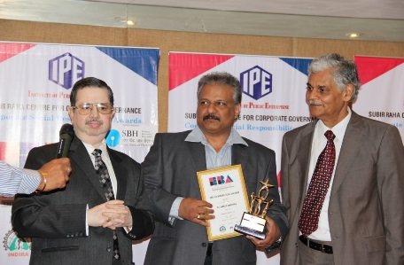
- He has received another award for his contribution to the field of HR and selected him as one among the ‘100 Most Talented Global HR Leaders’ and received the Award from World HRD Congress - 2015.
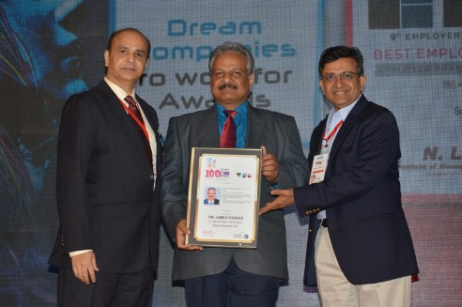
- He has received one more award from CHRO Asia as ’50 Most Influential Training and Development Professional’ in 2015.
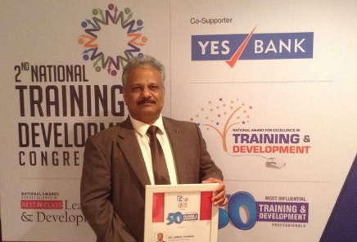;

An Appeal
Dear Friends

My sincere greetings to all the progressive thinking HR Professionals.

I have been associated with NIPM Chapters - Mysore as well as Karnataka for many years. For the last two years I have been a member in the Executive Committee as well as functioning as the Chairman of the Magazine and Publication committee, Karnataka Chapter.
In order to carry out the activities mentioned in the Election Manifesto along with other mandates of Karnataka Chapter is a very good task and I am sure along with other Executive Committee members I will be able to take up all activities with your co-operation and support.
I am sure there are competent contestants for the post of Chairman, however, I am the most suitable candidate for the position and I request your good self to cast your vote for me to serve you as well as Karnataka Chapter to improve the services of our Chapter as well as enhance the status of HR Profession.
I will be extremely happy to serve Karnataka Chapter and I request you to cast your vote in favor of me.
Yours truly
Dr. James Thomas
Life Member No.
www.drjames.in

